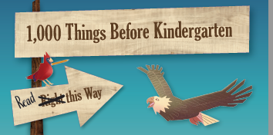

**Get your favorite little one ready to learn!**

Studies show that the more books a child has read to them and

the more books in a child’s home, the better they are able to learn.

**Start today:**

• Sign up any child aged birth to five years.

• Read a book or do a suggested activity (you’ll get a list when you sign up)

Every day to check off a box.

• Receive a FREE, brand new book to KEEP after every 100 books.